Assignment 3 Part D Submission Template

Name: Daljeet Singh

Student #: 3169763

D.1 Write a single SQL statement that is equivalent to the logic expressed by the following relational algebra statements.

SELECT e.emp_id as id,
e.lname as Last,
s.ann_sal * 0.05 + s.ann_sal as NewSalary,
s.ann_sal as CurrentSal,
s. ann_sal * 0.05 as PayRaise
FROM
Employee e
JOIN
Salary s ON e.emp_id = s.emp_id
WHERE
e.year_experience >= 5 AND s.salary_is_active = true;

D. 2 Write the relational algebra expression(s) for the following SQL statement.

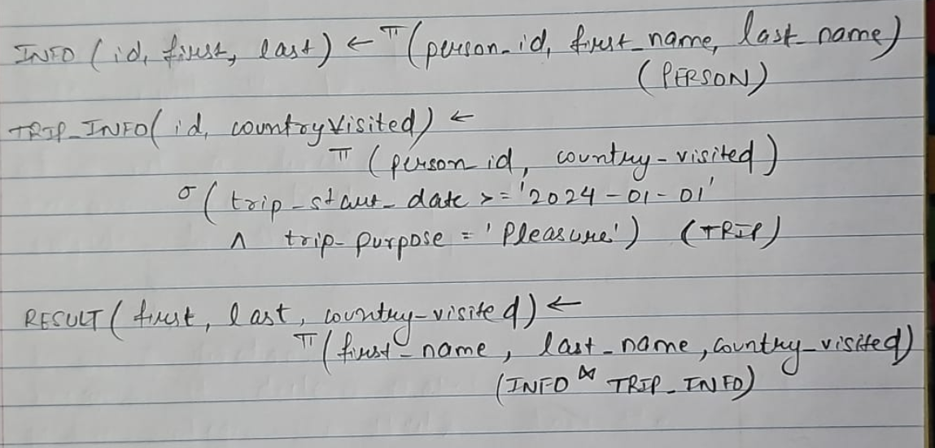

D. 3 Prepare an optimized query tree for the following SQL Statement given the following assumptions:

